Ben Douglas

02-26-2025

8-1 Assignment: Data Aggregation Pipeline- Assignment

Here are the screenshots of AdventNet:

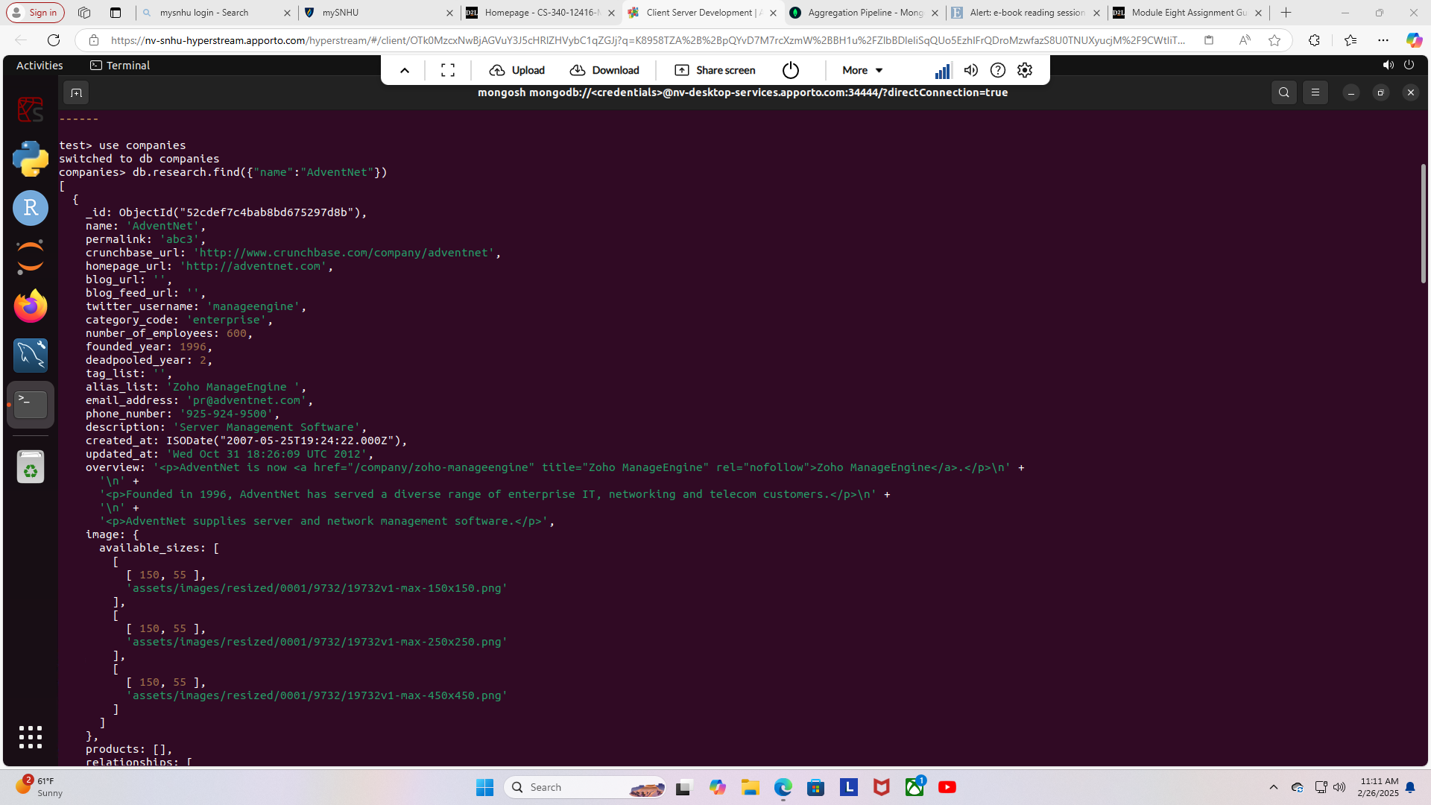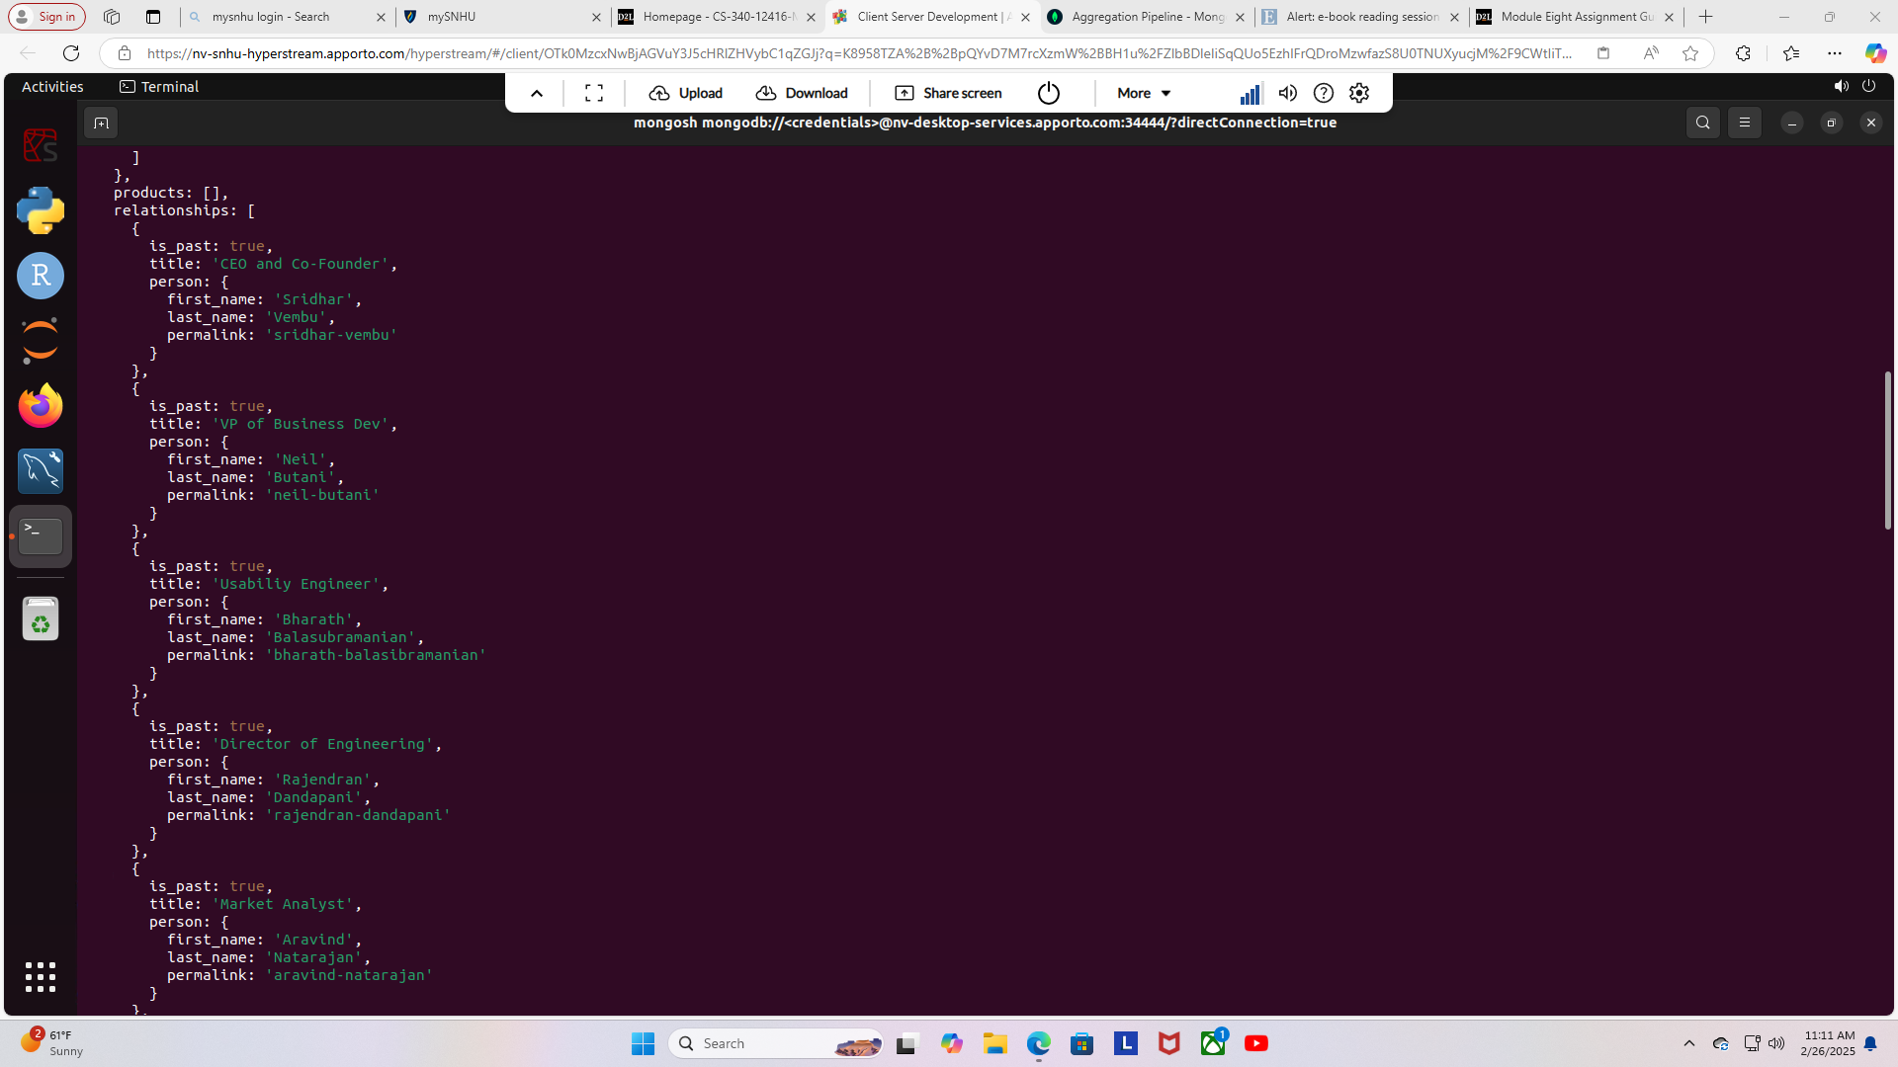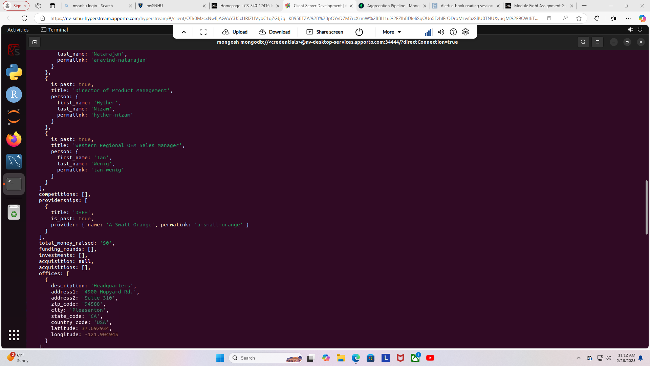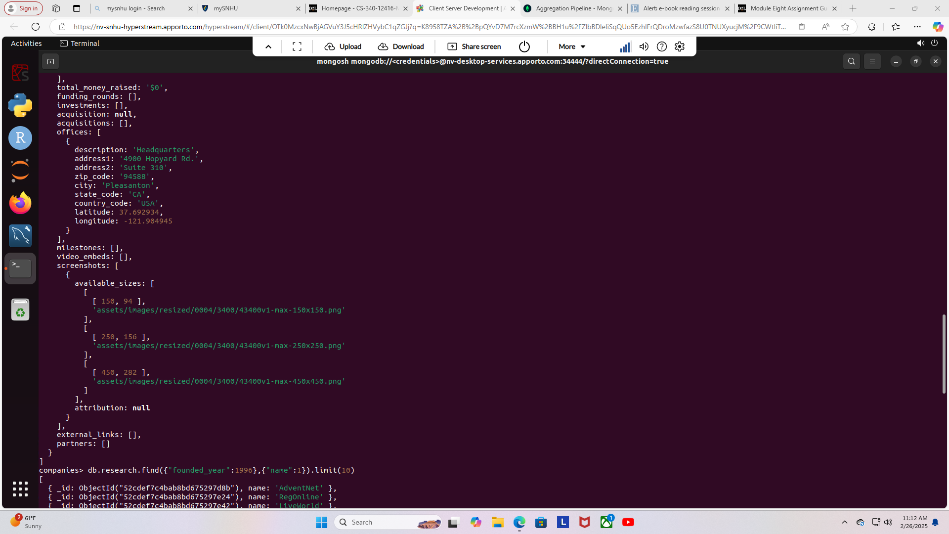Here is the screenshot to the founded year, and name:

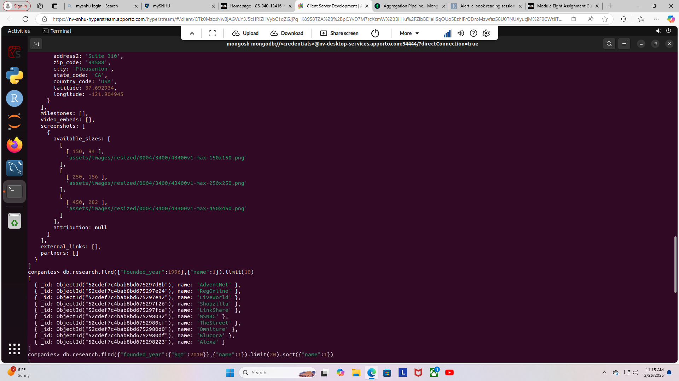Here is the screenshot of the year 2010’s companies:

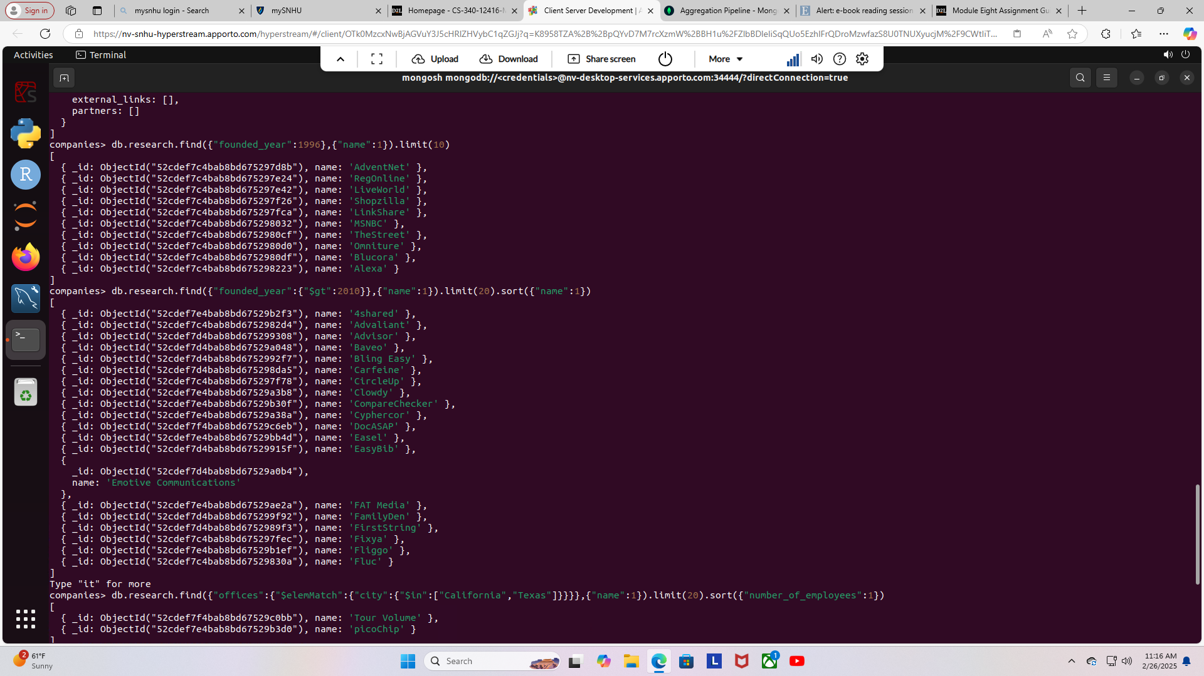Here is the screenshot of California and Texas companies:

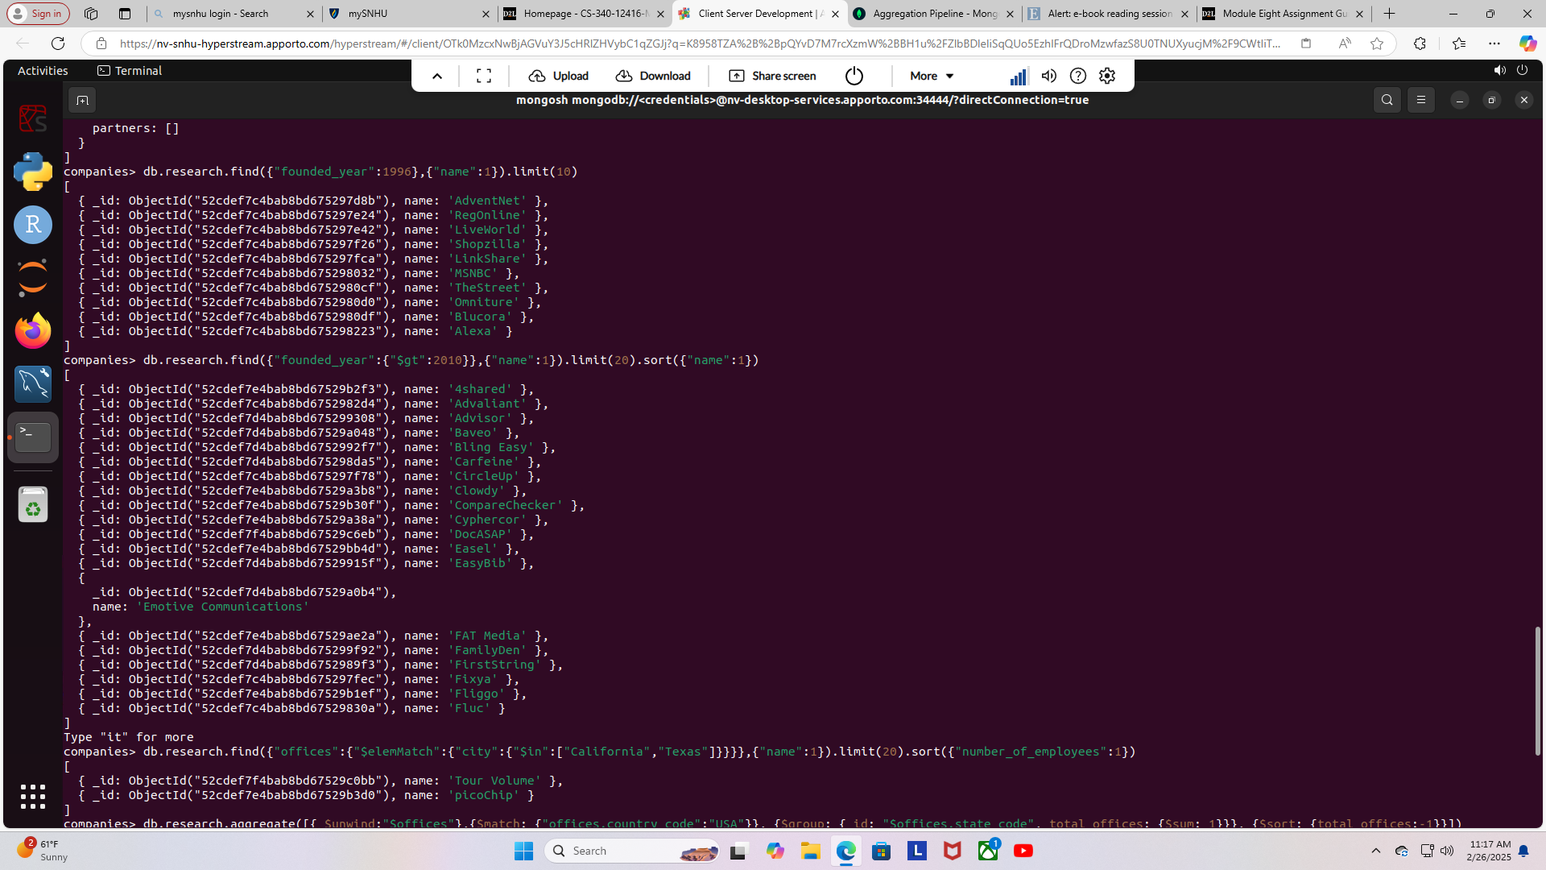Here is the screenshot of aggregate offices:

